**AIHarvest Hub – Conveys a hub where AI meets agriculture for direct**

**consumer access**

Namratha S

20/12/2024

**Abstract**

AIHarvest Hub is an innovative producer-to-consumer platform that leverages artificial intelligence to connect farmers directly with consumers, transforming traditional agriculture distribution channels. Designed to enhance transparency, efficiency, and sustainability, AIHarvest Hub empowers local producers by providing a direct sales channel where consumers can order fresh, traceable produce with ease. Key features include real-time inventory updates, product traceability, and farmer profiles, which foster trust and connection between consumers and producers. By integrating AI-driven logistics and analytics, AIHarvest Hub optimizes the delivery process, reducing costs and ensuring timely delivery of fresh, high-quality products. This platform serves as a comprehensive hub for modern agriculture, bridging the gap between farms and consumers while promoting sustainable and locally-sourced food systems.

**1. Business Model**

**Objective:** Establish a practical and sustainable revenue model for AI Harvest Hub.

**Proposed Revenue Streams:**

1. **Subscription Model:**
   * Premium plans for farmers and consumers.
   * Offers advanced analytics, AI-powered insights, and educational resources.
2. **Transaction Fees:**
   * A small percentage of each transaction conducted on the platform.
3. **Freemium Model:**
   * Basic features are free, while advanced features are available for a fee.
4. **Sponsored Listings:**
   * Producers pay to highlight or prioritize their products.
5. **Advertisements:**
   * Partner with agriculture-related businesses for targeted ad placement.
6. **Data Monetization:**
   * Provide anonymized data insights to third parties such as agricultural companies, NGOs, or governmental bodies.

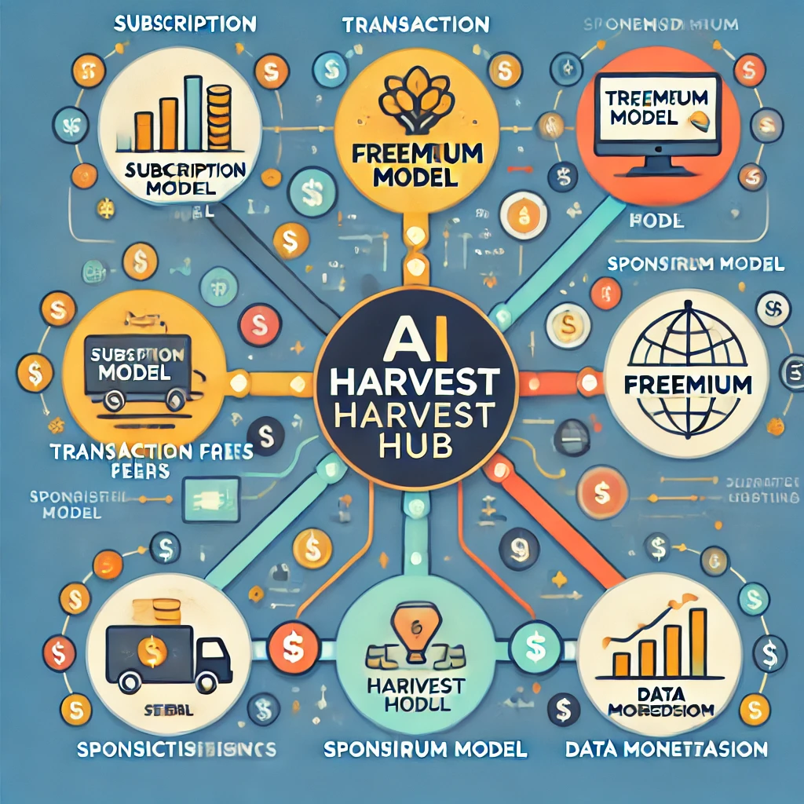

**2. Financial Equation**

**Defining Revenue with Key Variables:**

**Where:**

* : Total Revenue.
* : Number of subscribers.
* : Subscription price per user.
* : Total transactions on the platform.
* : Transaction fee percentage.
* : Number of sponsored listings.
* : Price per listing.
* : Number of ads sold.
* : Price per ad.
* : Amount of data insights sold.
* : Price per data insight package.

This equation serves as the foundation for revenue projection and financial planning.

For AIHarvest, a producer-to-consumer app, the financial equation can incorporate different revenue streams and costs. Assuming a structure similar to your earlier example, here's how it could look:

**General Financial Equation for AIHarvest**

y = P x − C

Where:

* y: Total profit or revenue (Rs.)
* P: Average revenue per transaction (Rs. per unit or sale)
* x: Number of transactions (units sold)
* C: Total fixed costs (Rs.)

**Expanded AIHarvest Model**

In AIHarvest, you may have multiple revenue streams. Let's break it down:

1. **Revenue Per Transaction (P):**
   * Subscription fee revenue (P1​)
   * Transaction fee revenue (P2​)
   * Advertising revenue (P3​)

So, P = P1 + P2 + P3

**Fixed Costs (C):**

* + Platform development and maintenance costs (C1​)
  + Marketing and operational costs (C2​)
  + Logistics and delivery costs (C3​)

So, C = C1 + C2 + C3

1. **Final Financial Equation:**

y= (P1+P2+P3) x− (C1+C2+C3)

**Simplified Example for AIHarvest**

Let’s assume:

* Subscription fee revenue per user (P1​): Rs. 100
* Transaction fee revenue per sale (P2​): Rs. 50
* Advertising revenue per user (P3​): Rs. 20
* Fixed costs (C): Rs. 5,000
* Number of sales (x): 200 transactions in a month

Substituting values:

y=(100+50+20)(200)−5000

y=170(200)−5000

y=34,000−5000=29,000 Rs.

This gives the total profit or revenue for the month.

Here’s the graph showing **Total Revenue (y)** as a function of the **Number of Active Users (u)**. The revenue increases linearly with the number of users, demonstrating the impact of subscriptions on overall profitability.

Key insights:

* The break-even point occurs where the revenue crosses the x-axis (revenue equals costs).
* Adding more active users significantly increases total revenue due to the high subscription price.

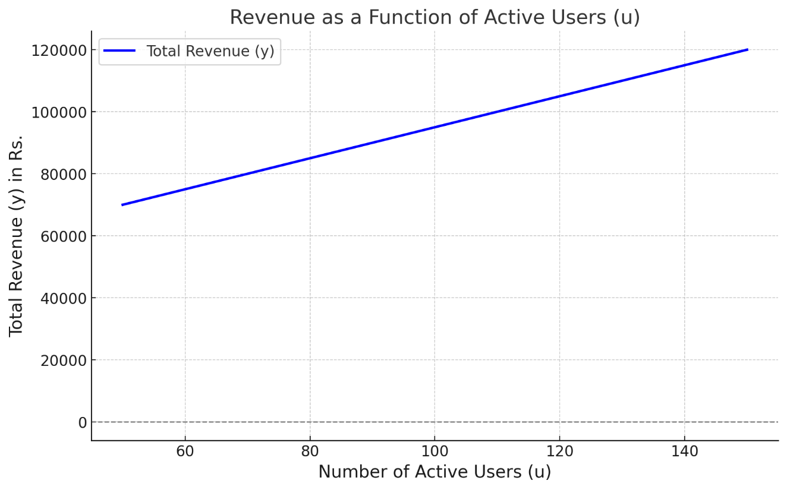

**3. Market Segmentation**

**Objective:** Identify key user groups for AI Harvest Hub based on characteristics and needs.

**Target Groups:**

**Producers (Farmers):**

* **By Size:** Small, medium, and large-scale farmers.
* **By Type:** Organic vs. conventional farming.
* **By Region:** Based on agricultural produce types (e.g., grains, fruits, vegetables).
* **By Digital Readiness:** Tech-savvy vs. traditional farmers.

**Consumers:**

* **Demographics:** Age, income level, and geography (urban vs. rural).
* **Preferences:** Organic food lovers, cost-conscious buyers, or those valuing direct-from-farm produce.
* **Purchase Frequency:** Regular buyers vs. occasional buyers.

**Businesses:**

* Small restaurants, grocery stores, and food manufacturers seeking fresh, direct farm produce.

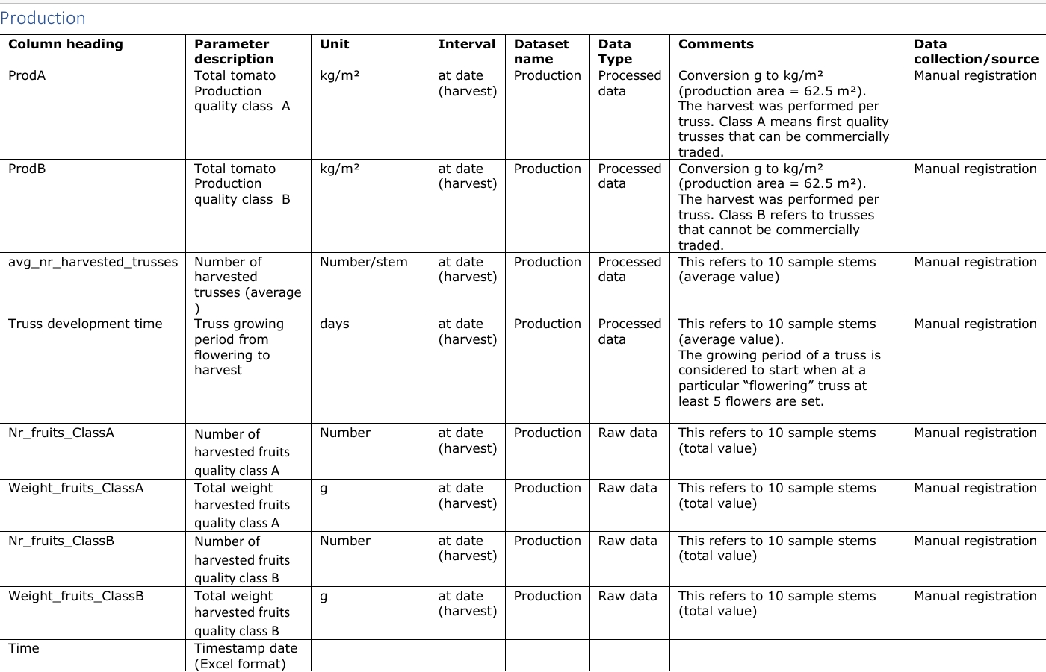

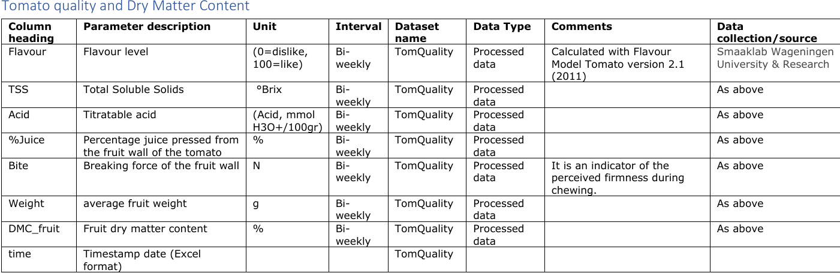

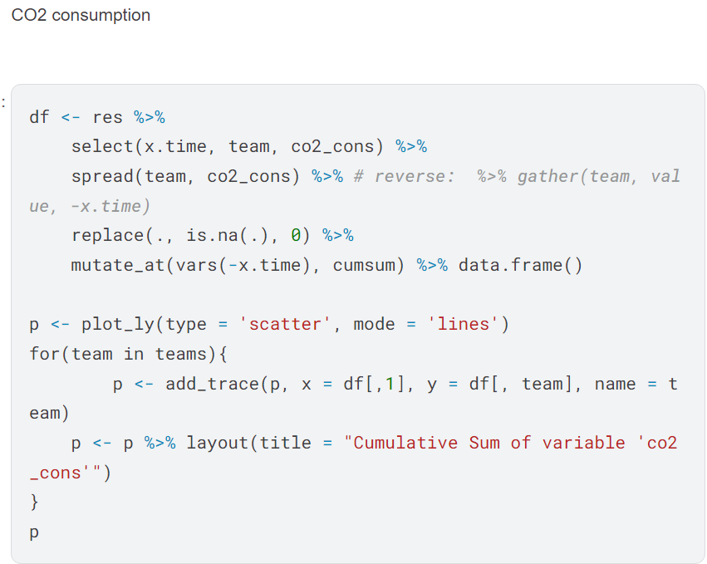

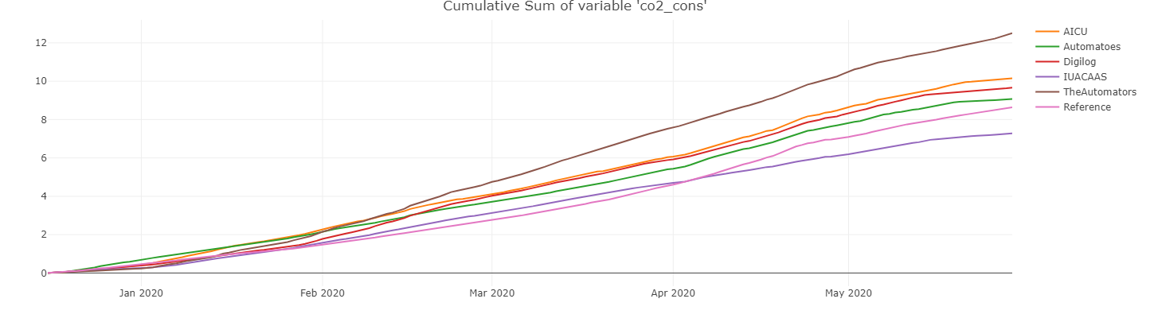

**5. Machine Learning Model**

**Objective:** Validate the product idea using an ML model for pricing, demand forecasting, and user matching.

**Proposed Features/Variables:**

* **Inputs:**
  + Farm location, produce type, quantity, quality rating.
  + Consumer preferences, location, and order history.
  + Market demand trends and seasonality data.
* **Outputs:**
  + Optimal pricing recommendations.
  + Demand forecasting for specific produce.
  + Efficient matching between producers and consumers.

**ML Approach:**

1. **Price Prediction & Demand Forecasting:**
   * Use supervised learning models (e.g., linear regression, random forest).
2. **User Matching:**
   * Employ recommendation systems (e.g., collaborative filtering).

**Prototype Implementation:**

* Develop a small-scale Python script:
  + Data preprocessing.
  + Build regression or classification models.
  + Implement a basic recommendation algorithm.

**Conclusion**

AI Harvest Hub has the potential to revolutionize the agriculture industry by empowering producers and consumers through direct engagement, enhanced transparency, and optimized supply chains. By leveraging a robust business model, advanced analytics, and machine learning, the platform can address key challenges in the sector while providing sustainable revenue streams.